**PROCESS**

* A process is a program in execution.
* Execution of process must progress in a sequential order.
* is defined as an entity which represents the basic unit of work to be implemented in a system.
* A process can be divided into 4 sections.

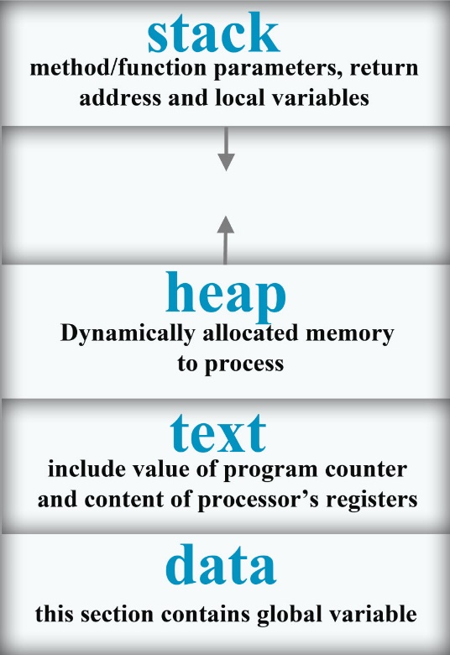

STACK

Process stack contains the temporary data such as methods/ function parameters, return address and local variables.

HEAP

It is a dynamically allocated memory to a process during its runtime.

TEXT

This includes the current activity represented by the value of program counter and the contents of the processor’s registers.

DATA

This section contains the global and static variables.

**PROCESS STATE/ LIFE CYCLE**

As a process executes, it changes state.

1. NEW STATE

The process is being created.

1. READY STATE

The process is waiting to be assigned to processor.

1. RUNNING STATE

Instructions are being executed.

1. WAITING

Process moves into a waiting state if it needs to wait for a resource, such as waiting for user input, or waiting for a file to become available.

1. TERMINATED OR EXIT

Process has finished execution.

These state names are arbitrary, and they vary across Operating System.

